**GitHub Account Setup Guide**

GitHub Allied Solutions Organization

<https://github.com/allied-solutions>

GitHub Learning Path

<https://lab.github.com/githubtraining/first-day-on-github>

Now you will create a GitHub account.

The Allied Solutions’ Username policy is to prepend **“AS-”** before entering your Allied network username for continuity and security between systems, this will also allow a greater level of uniqueness among the rest of the GitHub community.

For example: **Tony Reynolds** would enter **as-treynolds**.

Enter your Allied email address and create a password for access to your GitHub account if prompted.

**NOTE:** There is no link between this GitHub password and your Allied password.

Click “**Create account and join**”.

This will create your GitHub account and link it to the Allied Solutions Organization.

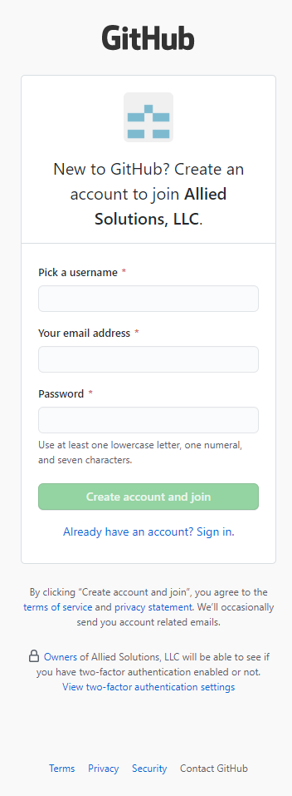

You will be asked to validate a CAPTCHA for your account after creation.

Verify your account and click “**Join a free plan**”.

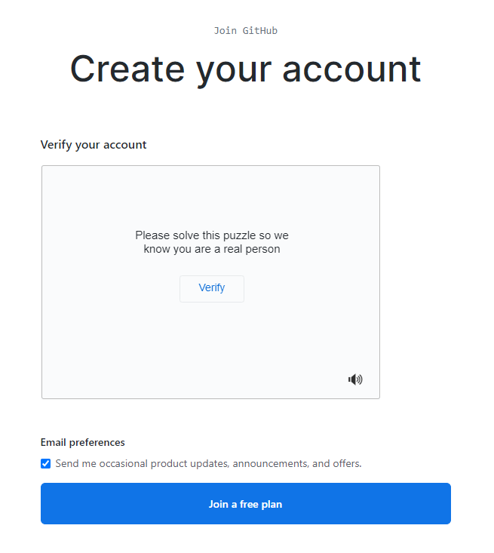

Although you are joining a free plan, your account will be assigned a GitHub Enterprise License for Visual Studio, this will allow you to connect to the Allied Solutions organization from Visual Studio.

You will receive an email from GitHub to verify your email address for your account.

Click “**Very email address**” and you will be taken to the Allied Solutions Organization dashboard.

**Follow this guide to create your Allied Solutions GitHub account:**

You will receive an email inviting you to join the **@allied-solutions** organization, this invitation email will expire 7 days after being sent.

After clicking the “**Join @allied-solutions**” button, you may be prompted to authenticate through Single Sign On, if so, login using your Allied credentials.

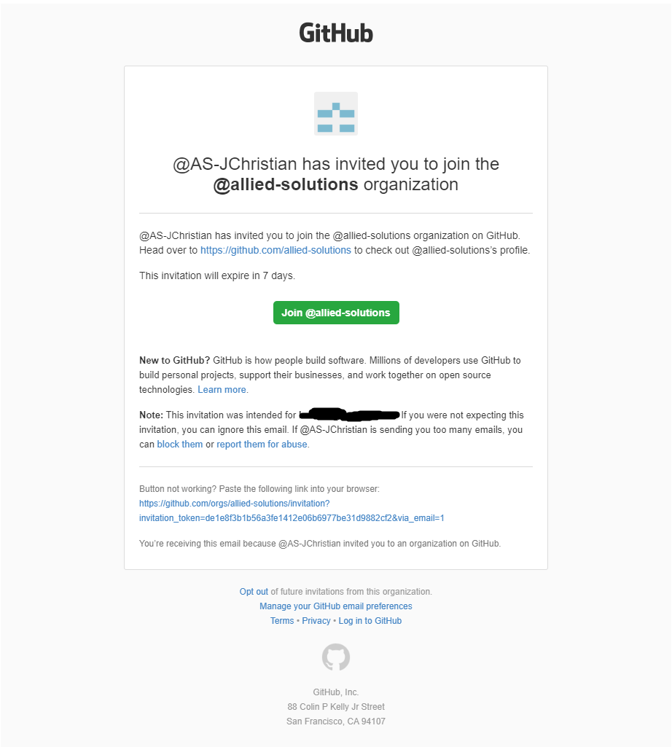

There are also links in the email with information about GitHub and the Allied Solutions organization.

This is the main dashboard for the Allied Solutions organization, from here you will be able to browse code projects, repositories and communicate with other users assigned to this organization.

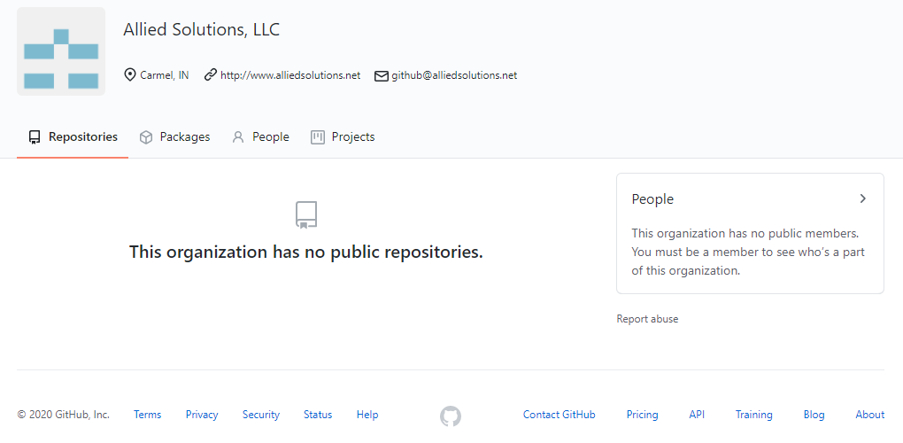

Please email [github@alliedsolutions.net](mailto:github@alliedsolutions.net) for problems or questions!

*GitHub is still under implementation; your account will be limited until the implementation is complete.*